Website Development Proposal
Online Store and Automatic Order System — Fancy Fragrances
Prepared for: Tsholofelo ("Tsholo") Kabasia, Founder — Fancy Fragrances
Prepared by: Reatlegile Kabasia
Date: August 2026
Target market: People who love quality perfumes and skincare products

1. Summary & Origin Story
Fancy Fragrances started in 2024 around a family kitchen table. Tsholo built the business with her three children. She named it after the nickname she has called her youngest daughter since birth. At its heart Fancy Fragrances is a family effort, offering good-quality perfumes and skincare at prices every family can afford
Tsholo runs everything herself packing orders, setting prices, and talking to customers at local markets. Her hard work has built a loyal group of 100 to 200 regular buyers. But doing all of this by hand takes a lot of time, and it is getting harder to keep up as sales grow
This proposal is a plan to build a simple, reliable online store. It will work day and night to take orders, answer basic questions, and handle broken bottle reports automatically… freeing up Tsholo’s time to grow the business and spend time with family

2. Business Goals
Mission. To bring good-quality perfumes and skincare to local communities with warm, personal service in person and online
Vision. To grow Fancy Fragrances from a popular market stall into a trusted online store, while keeping the family story customers love

3. Challenges We'll Solve
The Challenge | How the Website Helps
Slow reply times for messages | Messages come in all day, even when Tsholo is busy at markets or with family. The online store lets customers view products, order, and pay any time. A WhatsApp button stays there too, for quick questions.
Working out delivery by hand | Working out delivery costs and booking couriers by hand takes too much time. The website will work out delivery fees automatically at checkout, so customers see the exact cost right away
Losing customers after market days | Market customers don't always know how to reorder once their perfume runs out. Printable QR codes at the stall take customers straight to the online shop, so they can reorder easily
Damaged items reported in chat apps | Complaints about broken or leaking bottles get lost among normal messages. A simple online form lets customers send a photo of the damage so they get a fast refund or replacement

4. Recommended Platform
We suggest building the store on Shopify, or hosting a website on Netlify as a good alternative. Both are easy for Tsholo and her children to manage from a phone or computer adding products, changing prices, or posting market dates with no technical skills needed. They load fast on South African mobile networks and work safely with trusted local payment services like PayFast and Yoco

5. Key Website Features
Local Google Search & Market Map. Helps local shoppers find the brand on Google Search and Google Maps. It includes an easy market section where Tsholo can post the next weekend’s location
Quick Customer Contact Options. WhatsApp and click-to-call buttons for customers who like to voice out their concerns, plus a normal email form
Damaged Product Reporting Form. A simple page where buyers add details and a photo of a broken bottle, for fast service without endless back-and-forth messages
Customer Reviews & Trust Builder. Real comments from happy buyers, shown to put new shoppers at ease

6. Website Pages & Layout
Homepage Layout
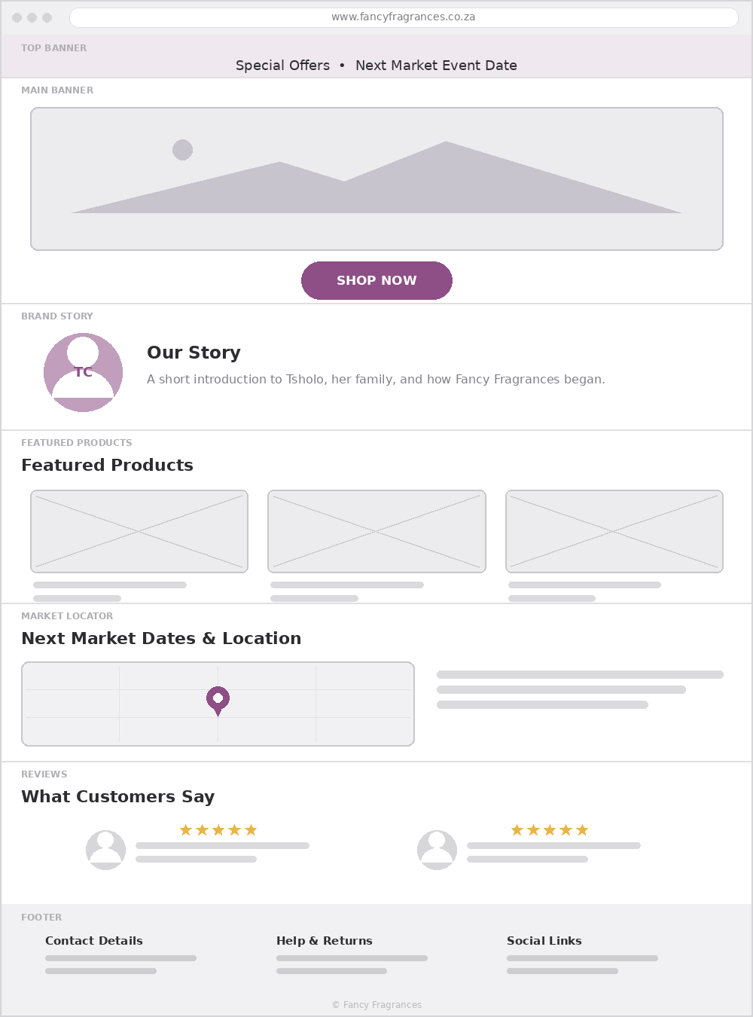

Shop Page (10 Items)
The shop page will have a clean, simple catalogue with filters for Perfumes and Skincare. Each product page will show scent notes, ingredients and how to buy
Damaged Item Report Form
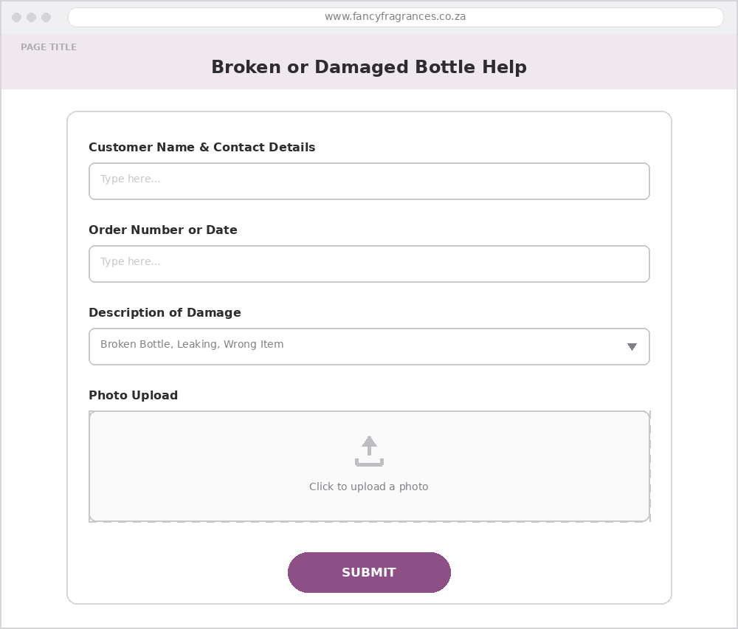

7. Expected Results
Focus Area | Target Result
Admin time | Cut by half much less time spent answering the same questions again and again
Repeat sales | Turn market shoppers into repeat online customers
Mobile speed | Pages load in under 3 seconds on a normal mobile connection
Damage claims | Sorted out quickly, within 24–48 hours

8. Investment
Item | Cost (ZAR)
Core website setup | R10,000 – R15,000
Design layout & styling | R5,000 – R8,000
Google setup & search visibility | R3,000 – R5,000
Monthly hosting & maintenance | R350 – R600 / month
Agreed arrangement: These are standard market prices, shown for reference. For Fancy Fragrances, we’ve agreed on a product trade instead — one perfume bottle and one skincare item — plus a lower fee, to support the business.

9. Five-Week Timeline
Weeks | Focus
Weeks 1–2 | Planning & gathering content — agree on the website layout, and collect product photos, fragrance notes, and prices for all 10 items.
Weeks 3–4 | Building the website — build the pages, set up payments, build the damaged item form, and test everything on mobile phones.
Week 5 | Testing & launch — test everything, show Tsholo and her children how to manage orders, and launch the website.

